FINANCE TRANSACTIONS AND LOANS DASHBOARD
Power BI Report
Dataset: DATASET 4
Submitted by: SWARNALAKSHMI J
Date: 23/10/2026
Dep: B.com (fintech and ai)

1. Introduction
This report documents the Power BI dashboard built for a finance dataset covering customers, accounts, loans and transactions. The dashboard, titled “Finance Transaction and Loans Dashboard”, brings the key banking metrics together on a single page so that a user can understand the overall financial position without going through the raw tables.

Objectives
- To summarise customers, accounts, loans and transactions through KPI cards.
- To compare account balances across account types.
- To understand the distribution of loans by loan status.
- To analyse transaction value and volume by transaction type and over time.
- To make the dashboard interactive through slicers.

2. Dataset Overview
The data model contains 11 related tables. Transactions, Loans, Accounts and Customers hold the core records, while the remaining tables are lookup tables that describe categories such as type, status, branch and address.
Table | Description
Customers | Customer records; linked to customer type and address.
Customer Types | Lookup of customer categories.
Addresses | Address details for customers and branches.
Branches | Bank branch details.
Accounts | Account-level records including balances.
Account Types | Lookup of account categories (e.g. TypeName, AccountTypeID).
Account Statuses | Lookup of account status (used to identify active accounts).
Loans | Loan records.
Loan Statuses | Lookup of loan status (StatusName).
Transactions | Individual transactions with date and value.
Transaction Types | Lookup of transaction categories (TypeName).

3. Measures Created
Seven DAX measures were created and are used across the dashboard:
Measure | Table | Used in
TOTAL CUSTOMERS | Customers | KPI card
ACTIVE ACCOUNTS | Accounts | KPI card
ACTIVE LOANS | Loans | KPI card
TOTAL TRANSACTION VALUE | Transactions | KPI card, bar chart, summary table, tooltip
TOTAL TRANSACTIONS | Transactions | Line chart, summary table, tooltip
TOTAL ACCOUNT BALANCE | Accounts | Column chart
TOTAL LOANS | Loans | Donut chart

4. Dashboard Design
The report has two pages: the main page, Finance Overview, and a hidden tooltip page, Transaction Tooltip. The main page is laid out with the title at the top, KPI cards beside it, charts in the middle and lower sections, and slicers and a summary table on the right.

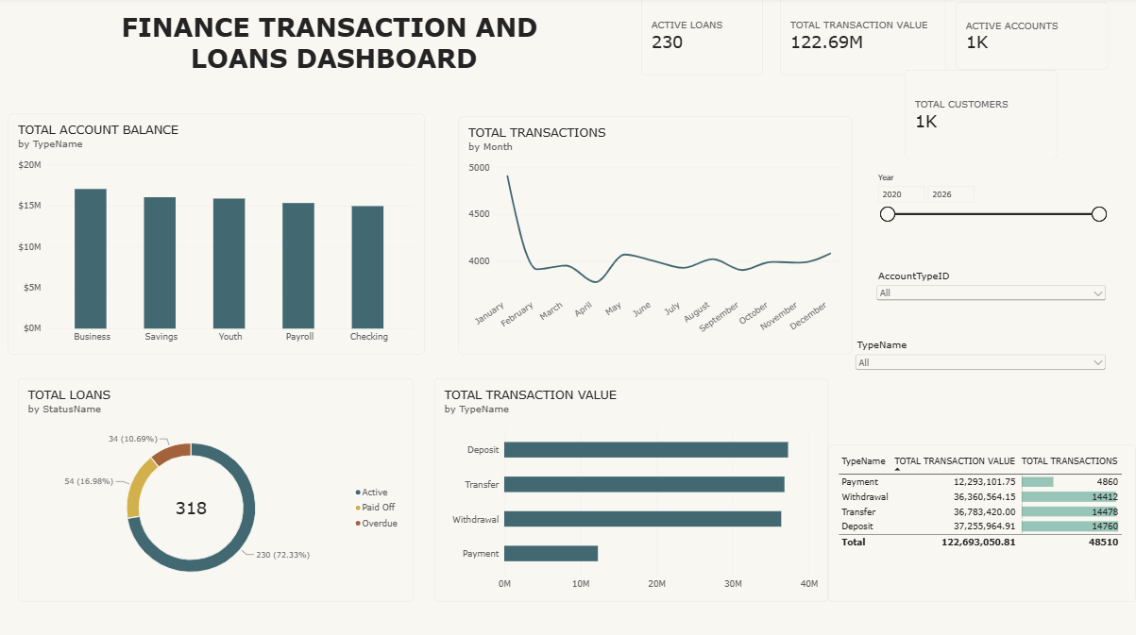KPI Cards
Four cards show the most important figures at a glance:
Card | Value | Meaning
Total Customers | [value] | Number of customers in the dataset
Active Accounts | [value] | Accounts currently active
Active Loans | [value] | Loans currently active
Total Transaction Value | [value] | Combined value of all transactions

These cards provide important information immediately without requiring the user to study the complete dashboard.

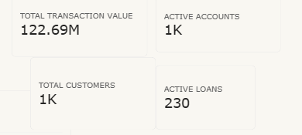

5. Visualizations Used

->Account Balance by Account Type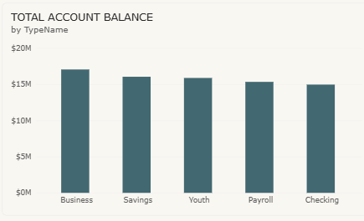
A Clustered Column Chart is used to compare the total account balance across the different account types, sorted from highest to lowest.
Purpose:
- To compare balances across account types.
- To identify the account types holding the most funds.
- To identify account types with low balances.

->Loans by Status
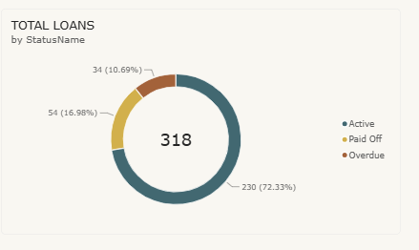
A Donut Chart is used to show how total loans are split across loan statuses.
Purpose:
- To understand the proportion of loans in each status.
- To monitor the share of active versus other loans.
- To highlight areas of risk such as defaulted or closed loans.

->Transaction Value by Transaction Type
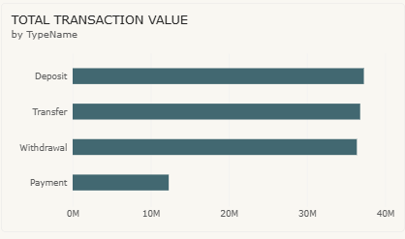
A Clustered Bar Chart is used to compare the total transaction value of each transaction type, sorted from highest to lowest. Hovering over a bar opens the custom tooltip page.
Purpose:
- To compare transaction types by value.
- To identify the most used transaction channels.

->Monthly Transactions Trend
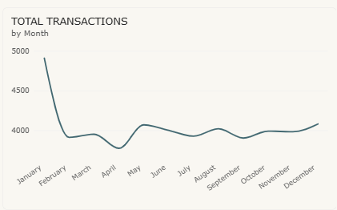A Line Chart is used to display the number of transactions month by month.
Purpose:
- To identify trends in transaction volume.
- To observe seasonal fluctuations.
- To identify periods of high and low activity.

->Transaction Summary Table
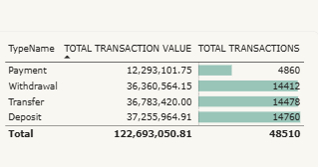
A Table lists each transaction type with its total transaction value and total number of transactions. Data bars on the transaction count column make the differences easy to compare.
Purpose:
- To show exact figures behind the charts.
- To compare value and volume together for each transaction type.

->Transaction Tooltip Page
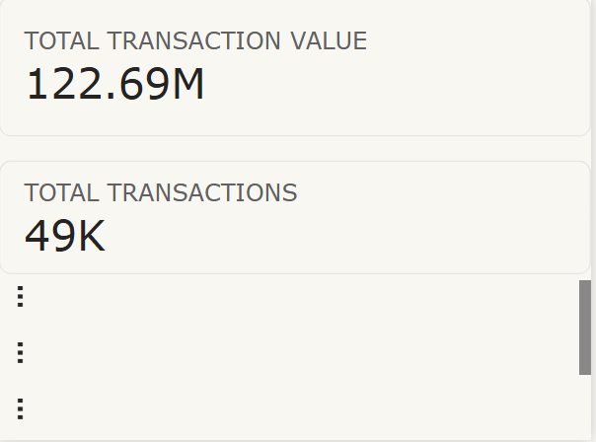
A custom tooltip page shows the total transaction value, the total number of transactions and the type name when the user hovers over a bar in the transaction value chart. This gives extra detail without adding more visuals to the main page.

6. Slicers Used
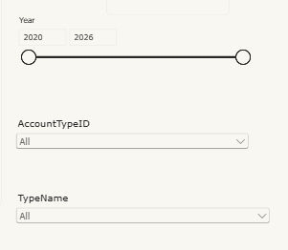
Three slicers were added to make the dashboard interactive:
- Account Type ID (dropdown)
- Account Type Name (dropdown)
- Transaction Year (range, “Between” mode)
These slicers allow users to filter the entire dashboard according to their requirements. For example, a user can select a particular account type or range of years and observe how all the charts change accordingly.

7. Conclusion
The Finance Transaction and Loans Dashboard presents customers, accounts, loans and transactions in a single, interactive view. KPI cards give a quick summary, the charts support comparison and trend analysis, and the slicers and tooltip page let users explore the data in more detail. The dashboard can support decisions on account management, loan monitoring and transaction analysis.

